IP address of a particular domain (guvi.in):

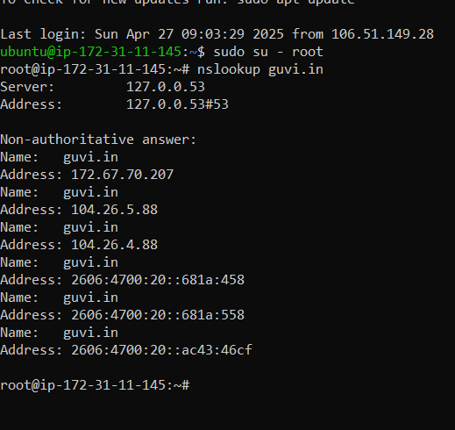

How do I find my CPU/memory usage of my server:

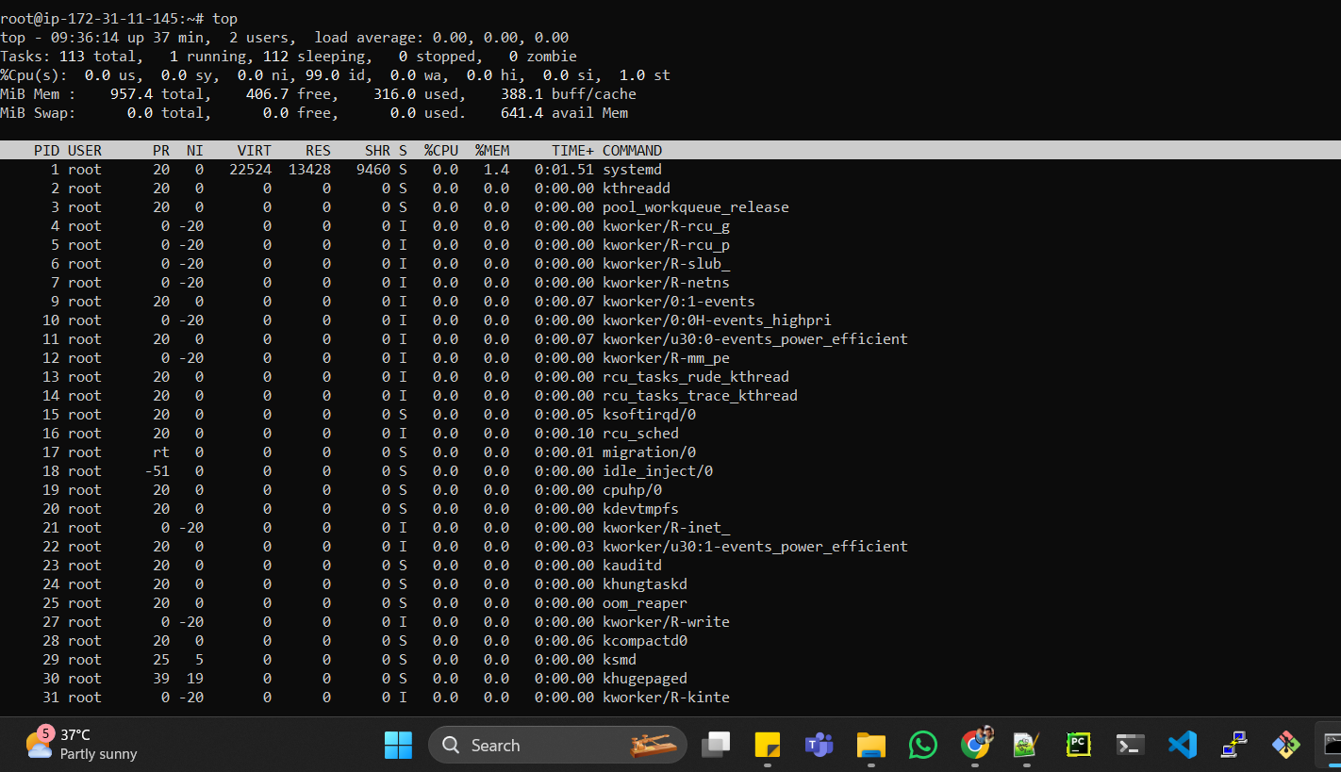

Test the connectivity between 2 nodes:

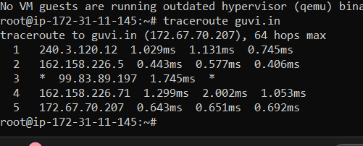

.I have deployed an application in guvi.com:9000, and logs show my app is running, but I’m unable to view the page. Check whether my port is open or not ?

Ans : it looks like port 9000 is not in use .

